МИНИСТЕРСТВО НАУКИ И ВЫСШЕГО ОБРАЗОВАНИЯ  
РОССИЙСКОЙ ФЕДЕРАЦИИ

федеральное государственное автономное   
образовательное учреждение высшего образования  
«Самарский национальный исследовательский университет   
имени академика С.П. Королева»

(Самарский университет)

Институт информатики, математики и электроники

Факультет информатики  
Кафедра суперкомпьютеров и общей информатики

**Отчет по лабораторной работе № 4**

Дисциплина: «Enterprise Systems Development (Методы проектирования и поддержки требований к программному обеспечению)»

Тип предприятия: **«Cinema chain»**

Выполнил: Мелешенко И. С.

Группа: 6133-010402D

Самара 2022

**СОДЕРЖАНИЕ**

1 Assignment #1. Sequence, State, Activity diagrams 3

2 Лабораторная работа №4. Sequence, State, Activity diagrams 4

# 1 Assignment #1. Sequence, State, Activity diagrams

Objective: To study the basics of Sequence, State, Activity diagrams

Addison Wesley - UML Distilled, 3rd Ed - 2003: "You should use sequence diagrams when you want to look at the behavior of several objects within a single use case. Sequence diagrams are good at showing collaborations among the objects; they are not so good at precise definition of the behavior. If you want to look at the behavior of a single object across many use cases, use a state diagram (see Chapter 10). If you want to look at behavior across many use cases or many threads, consider an activity diagram (see Chapter 11).

If you want to explore multiple alternative interactions quickly, you may be better off with CRC cards, as that avoids a lot of drawing and erasing. It's often handy to have a CRC card session to explore design alternatives and then use sequence diagrams to capture any interactions that you want to refer to later."

Tasks

1. Choose use case (use your Lab2 report) and create Sequence diagram for it.

2. Choose some object (or class) in your app and describe it behavior states change with State diagram. (Many people find that UI and control objects have the kind of behavior that is useful to depict with a State diagram).

3. Choose some process (or sub-process) and describe it with Activity diagram.

3. Compile resulting diagram images to doc report.

Notice

Grady Booch, James Rumbaugh, Ivar Jacobson Unified Modeling Language User Guide

# 2 Лабораторная работа №4. Sequence, State, Activity diagrams

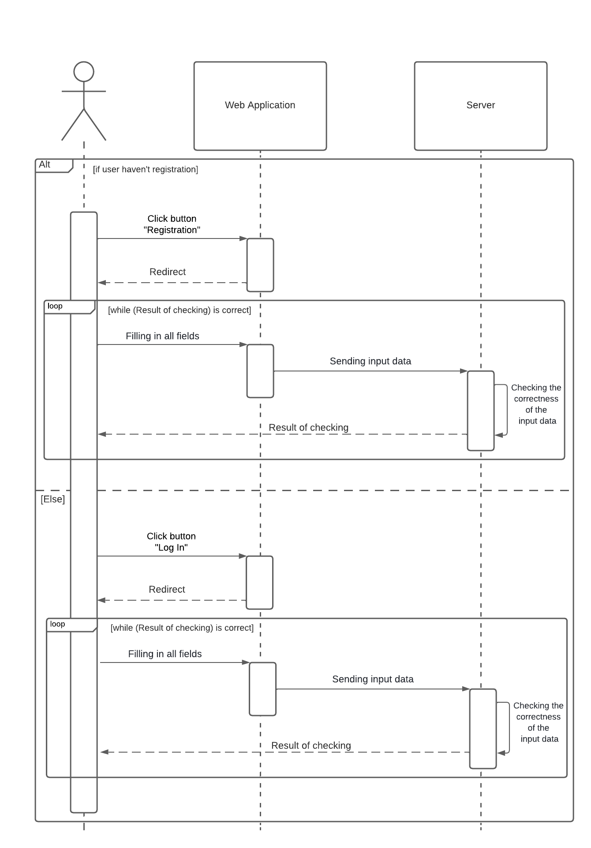  
Рисунок 1 – Sequence diagram

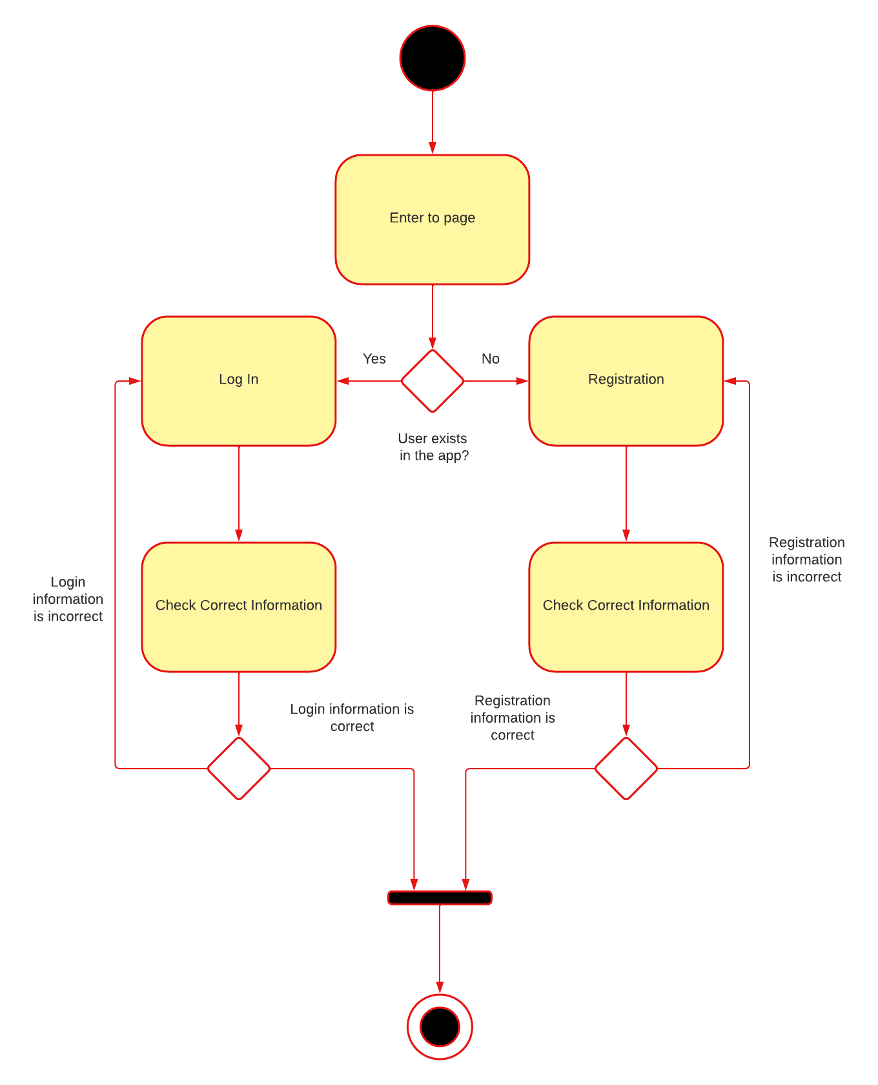  
Рисунок 2 – State diagram

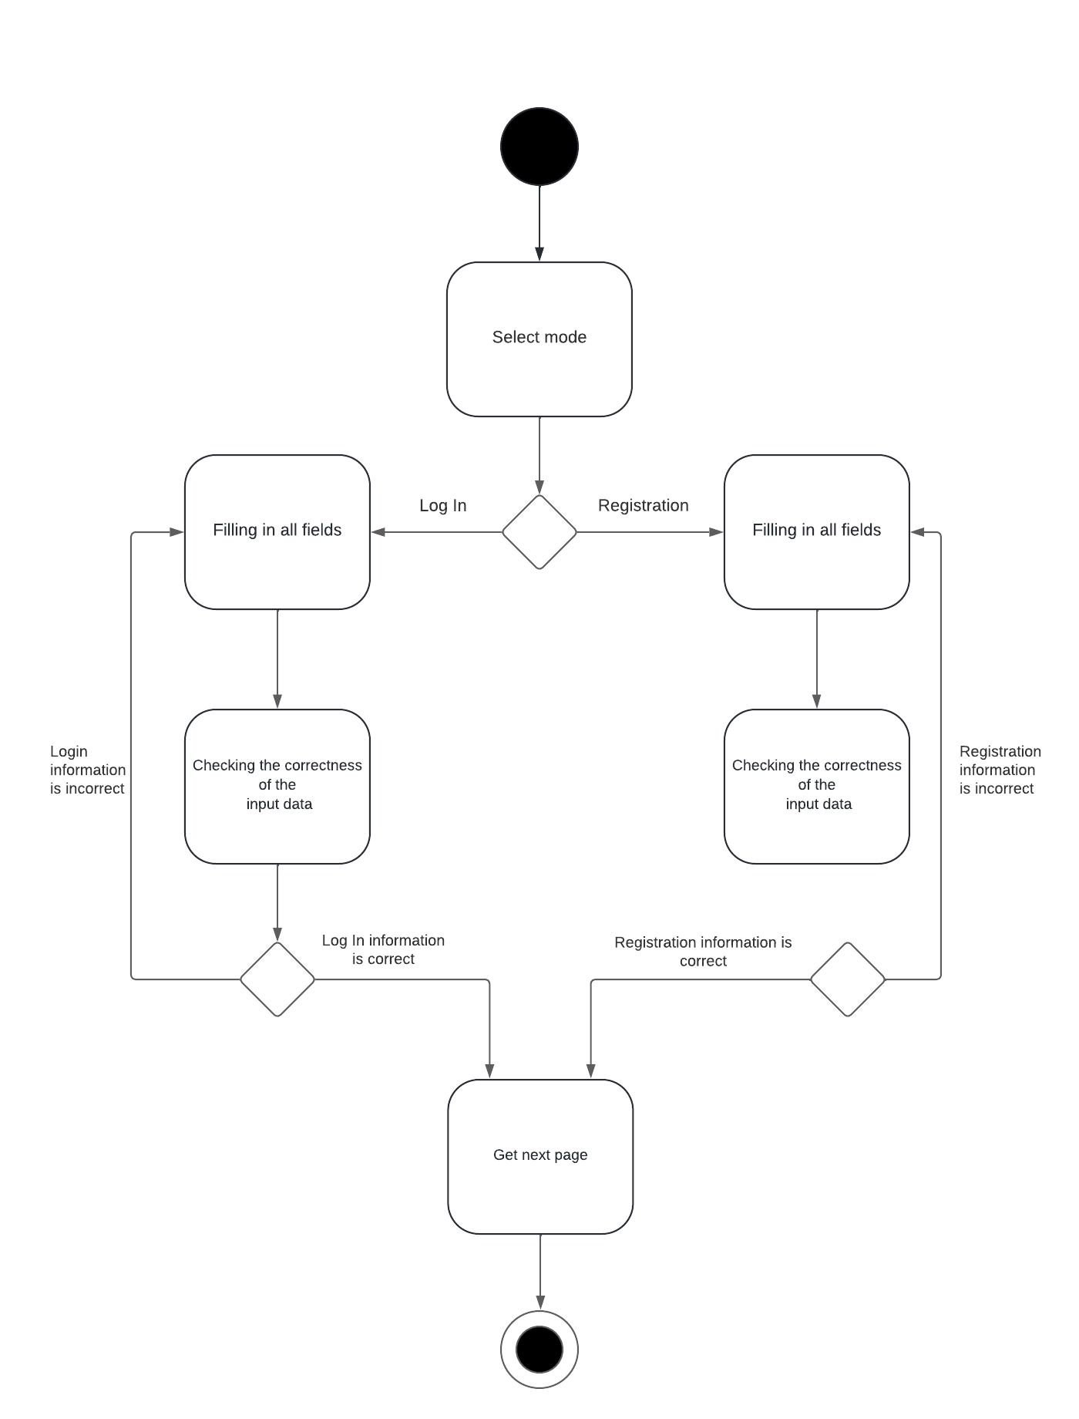  
Рисунок 3 – Activity diagram